A

Report

On

World Philosophy Day 2022

Session :2022-23

Department of Philosophy

Rabindra Mahavidyalaya,

champadanga, Hooghly

Theme: World Philosophy Day

Venue: Rabindra Mahavidyalaya

Department of Philosophy

Room no 71

Date:17th November 2022

Organizer: Department of Philosophy

Objectives:

- To give a clear understanding of various subjects
- Realizing the Value of philosophy
- For the development of thinking
- Stimulating intercultural dialogue
- Helping build a more tolerant and respectful society
- Revealing other talents

summary

On November 17th , 2022, World Philosophy Day was celebrated in the Department of Philosophy. First, Professor Hasina Sikdar of Philosophy Department the lamp lighting in front of Radhakrishnan's portrait. In the portrait, flowers and garlands were given by prof. Sukla Saha and prof. Soumitra Das. Then the students performed an opening song. A short cultural program of half an hour with dance, song recital etc. After that begins the educational program. A debate session was organized on this occasion. The topic was, advantages and disadvantages of using mobile. There were four teams and each team had three students. Students perform very well. The audience enjoyed it very much. They learn a lot.

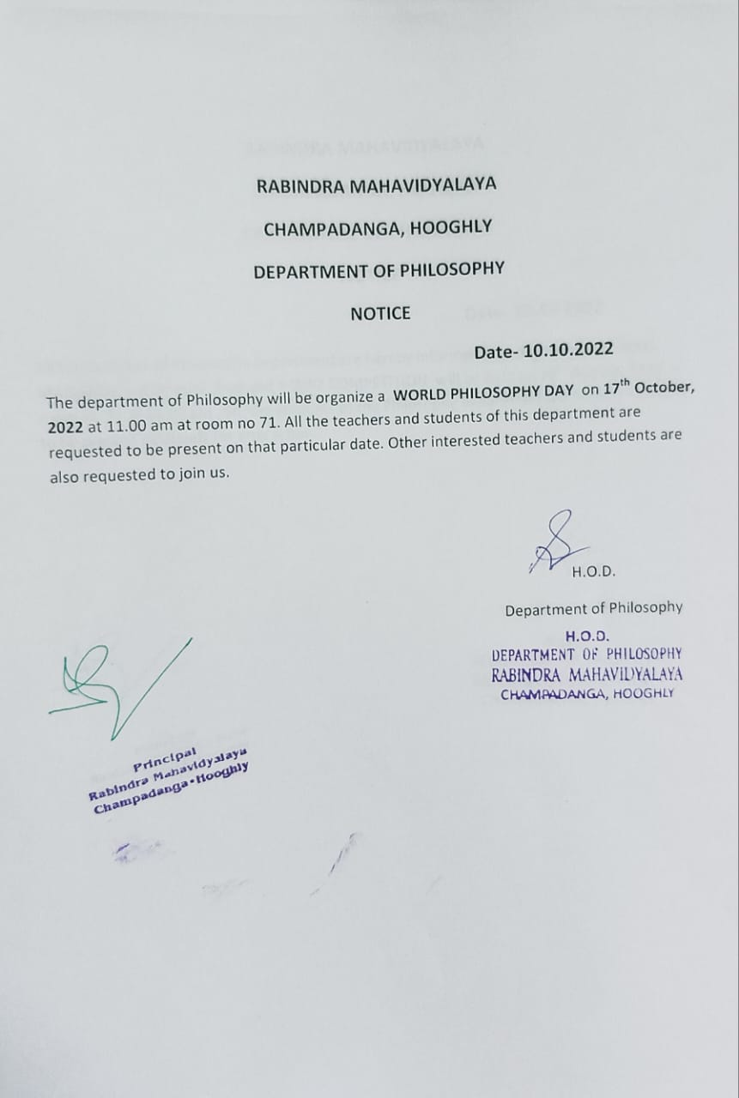

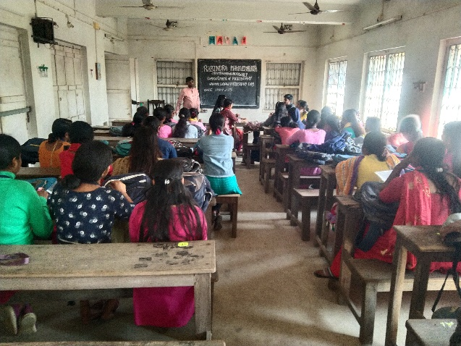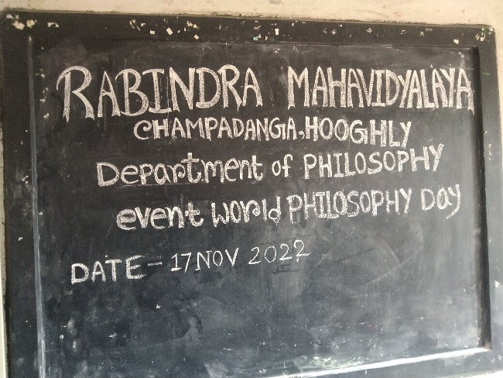
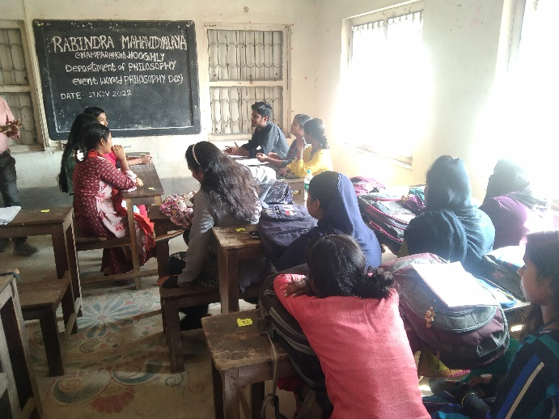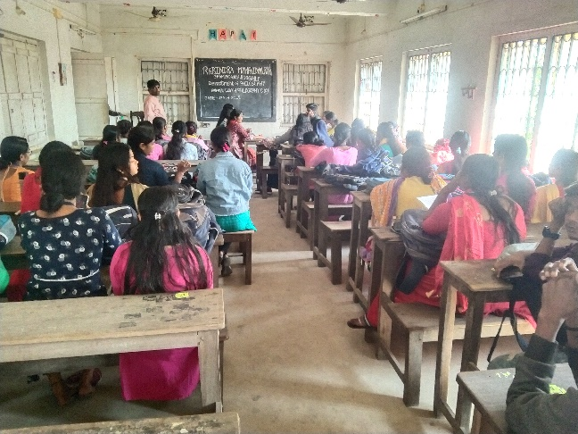

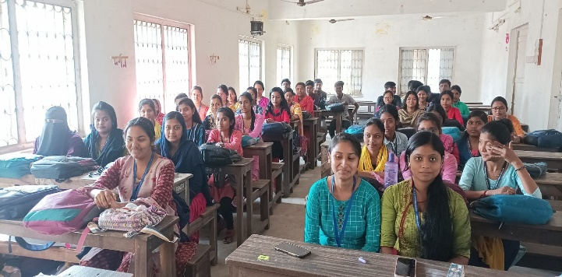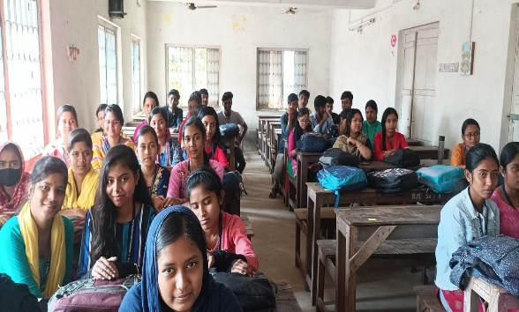
audience
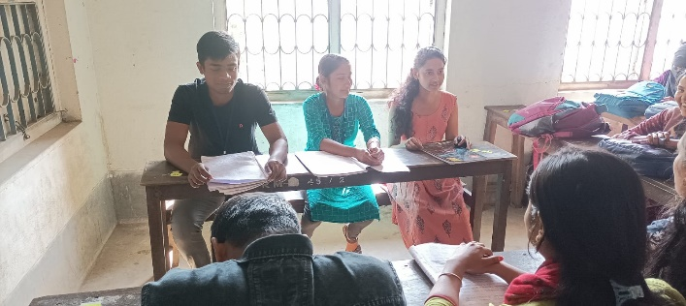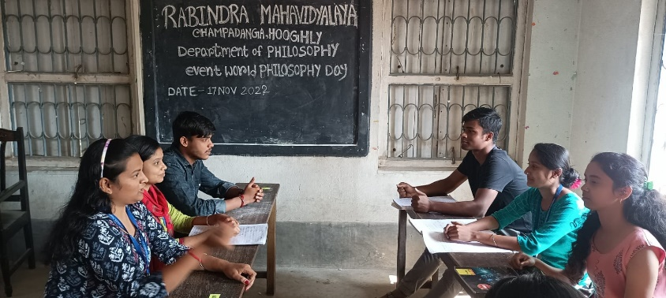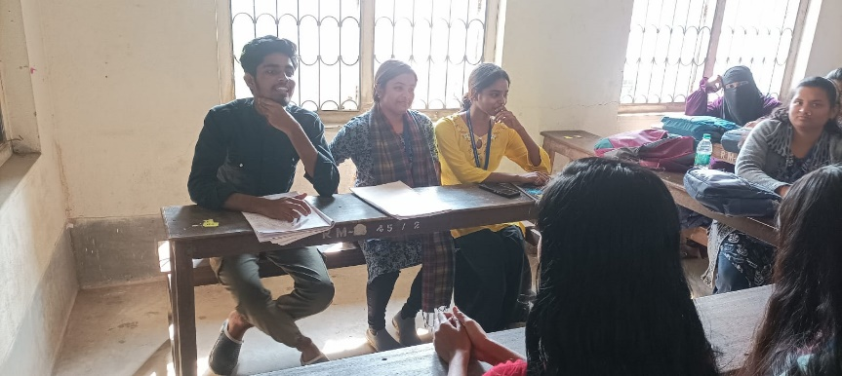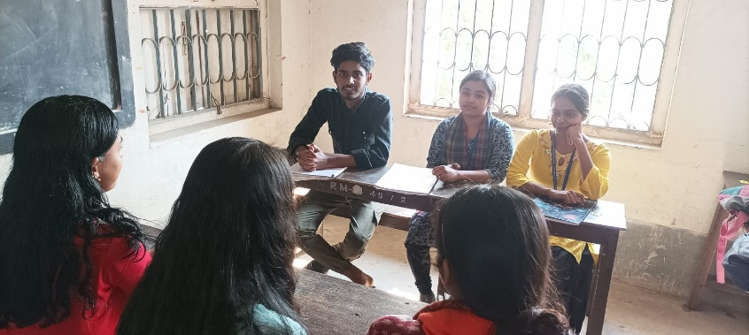
Debate team

Participants team: Team A
- Tripti Adhikari
- Anita Patra
- Arpita Das
Team B
- Sourav Jana
- Suparna Jana
- Mollika Malik

Team C

- Rikta Sasmal
- Rima Sasmal
- Bacchu Mohanto

Team D

- Soma Banarjee
- Sorbojit Patra
- Saheli Dolui

Our perticipent: 54
Male:10
Female:44

Tentative programme schedule
- Inaugural session: 11.30a.m. to 11.45a.m.
- Inaugural speech:11.45a.m. to 12 noon
- Other speech: 12noon to 12:30 p.m.
- Cultural programme: 12.30 p.m. to 1.00 p.m.
- Lunch break: 1.00 p.m. to 1:30 p.m.
- Debate: 1:30 p.m. to 3:30 p.m.

Feedback from students:

- 60% felt satisfactory
- 70 percent wished to occur the event more than once every year
- 100 percent students agreed this event helpe to improve their logical performance
- They want special class for grooming, more extra-curricular activities
- They want smart class room

